CHRISTMAS SERVICES AT ST MARY'S, WIX
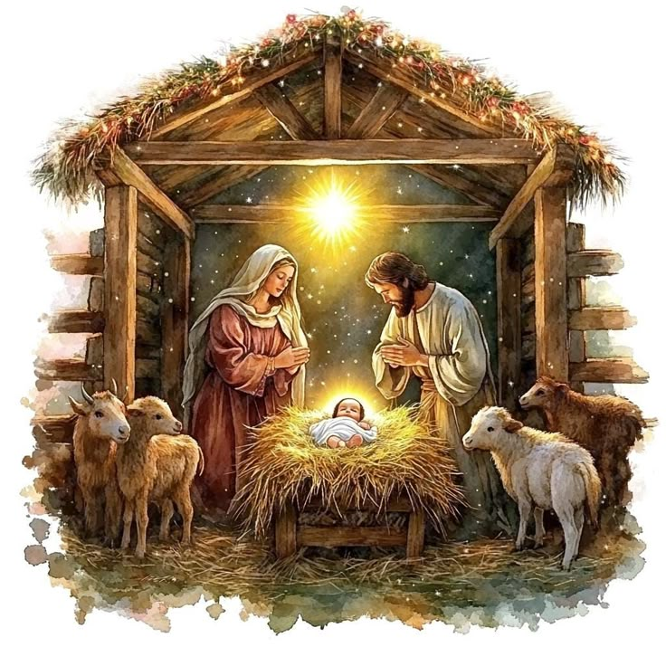

14TH DECEMBER
3 PM CAFE CHURCH IN THE VILLAGE HALL
16TH DECEMBER
4.30 PM WIX AND WRABNESS SCHOOL CAROL SERVICE
21ST DECEMBER
3 PM TRADITIONAL CANDLELIT CAROL SERVICE FOLLOWED BY MULLED WINE AND MINCE PIES
24TH DECEMBER
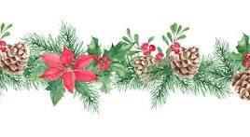
3 PM CRIB SERVICE WITH CAROLS

