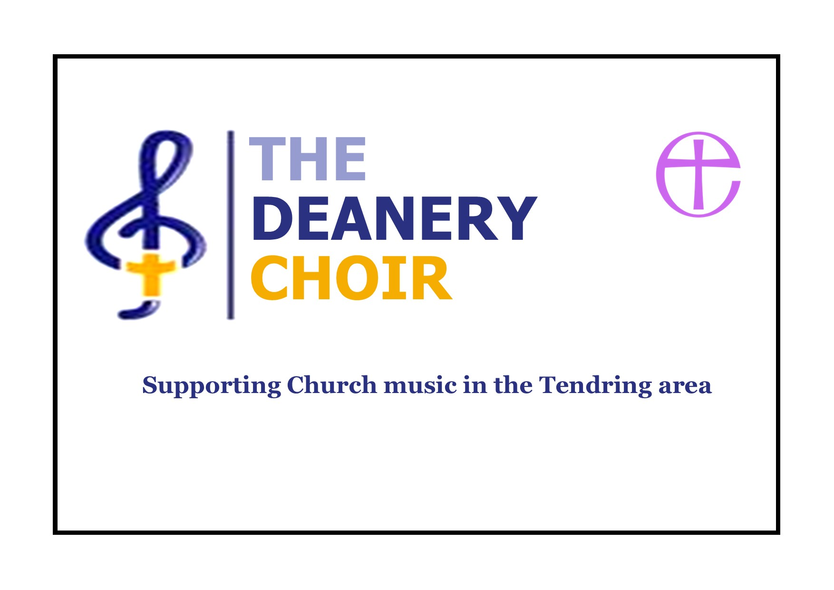

DECEMBER DIARY 2025

Dec 7th
The Deanery Choir will be singing at St Nicholas Church, Harwich CO12 3DR at the 3pm Patronal service. The choir will sing the anthem ‘A hymn to the Virgin’ by Benjamin Britten. Britten was born in Lowestoft, Suffolk, the son of a dentist. He showed talent from an early age. He studied at the Royal College of Music in London and privately with the composer Frank Bridge. Britten first came to public attention with the a cappella choral work ‘A Boy Was Born’ written in 1934. With the premiere of Peter Grimes in 1945, he leapt to international fame. Over the next 28 years, he wrote 14 more operas, establishing himself as one of the leading 20th-century composers in the genre.
Dec 13th (Saturday)
The Deanery Choir will be singing at their annual event ‘A living Christmas ‘25’ at St Osyth Parich Church, St Osyth CO16 8NU at 7pm. This concert tells the Christmas story with readings and music all of which is written by contemporary composers and arrangers. The choir is accompanied by Peter Clayton and a leaving collection will be made for church funds. One not to miss!
Dec 14th
The Deanery choir will be singing at St Georges Church, Great Bromley CO7 7TS at the 11am communion service. The choir will once again sing ’A hymn to a virgin’ by Benjamin Britten. This service will have music and hymns preparing us for the birth of Christ.

Graham Bell
Deanery Choir
grahambell493@gmail.com

